In today’s NFL games, despite the use of scientifically advanced helmets, professional players are suffering from the effects of injuries to their head. We are hearing stories about players and former players that have had life-changing injuries from the game of football. Mark Lovell, PhD, founding director of the University of Pittsburgh Medical Center Sports Medicine Concussion Program says that even injuries from "A minor hit on the field can take a long time to recover." 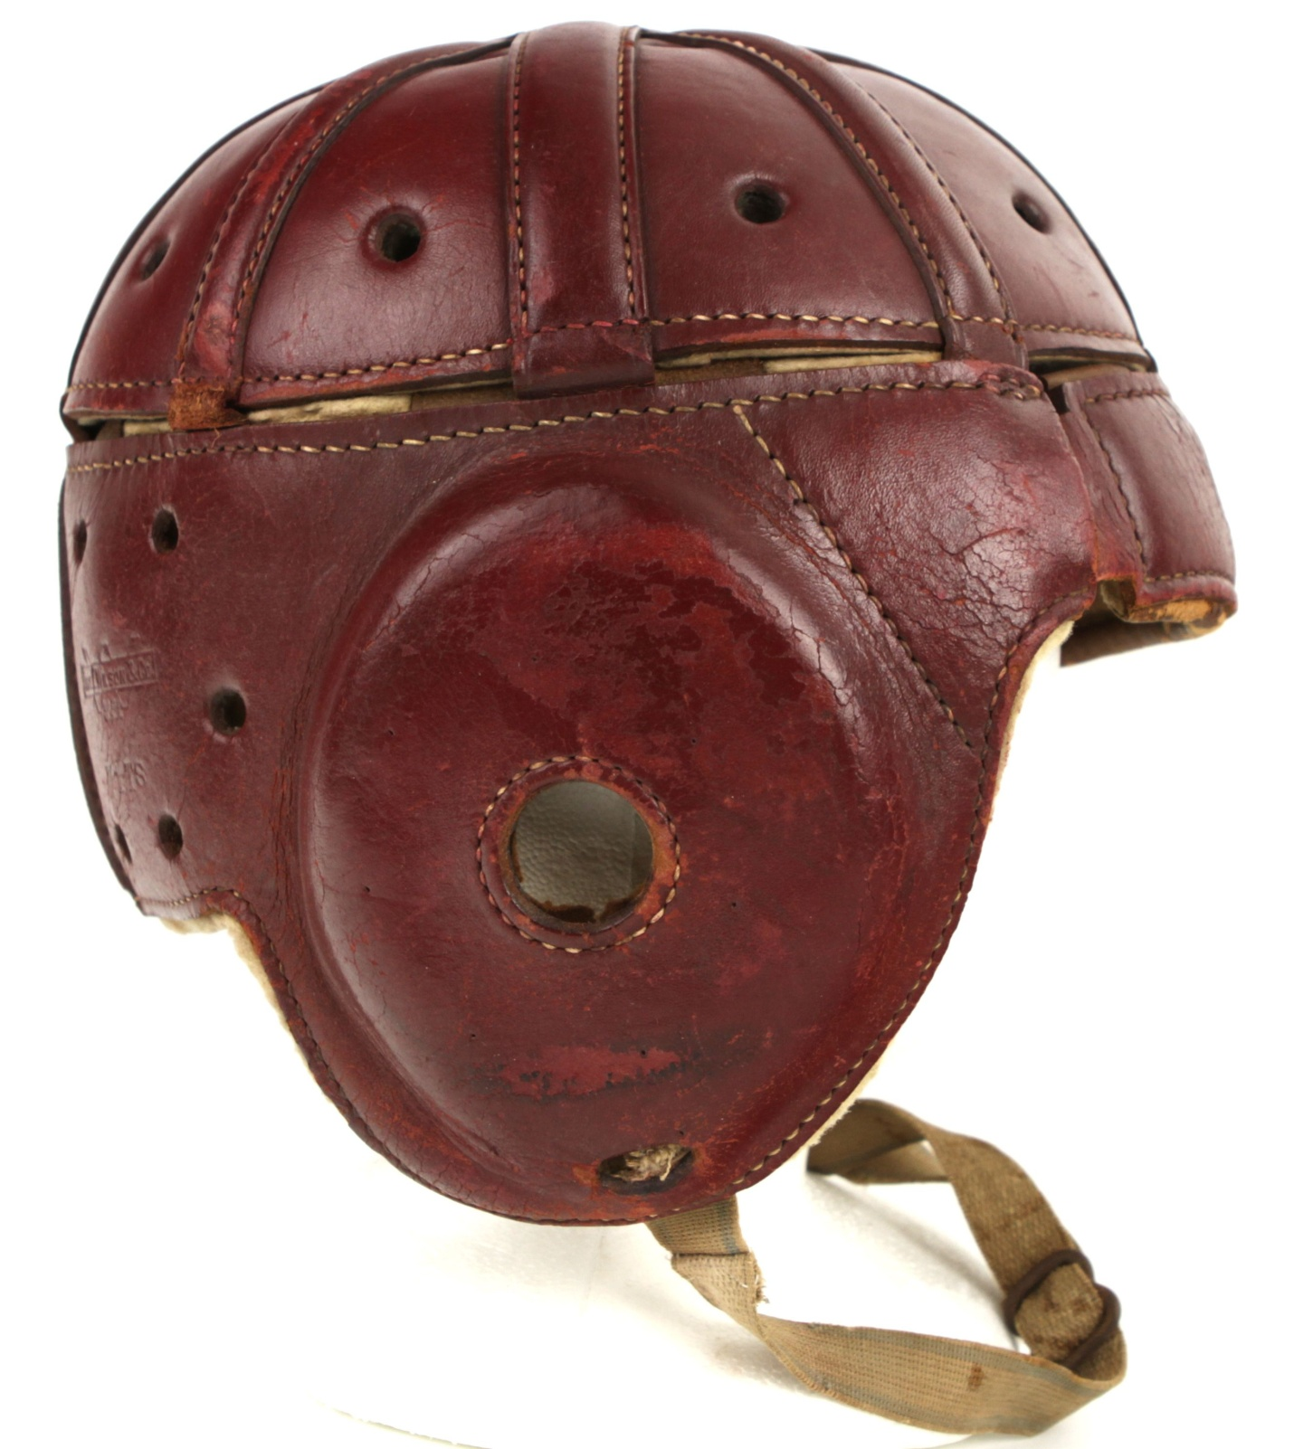
What is a concussion? It is trauma to the head that shakes the brain forcefully inside the skull. Symptoms can include loss of consciousness, drowsiness, confusion, headaches, nausea, blurred vision and loss of memory. The head is a very vulnerable area of the body and we see how rightfully so it is protected in the military, sports activities and even on construction sites with the use of some form of head-gear or helmet.
As professional Christians, we who profess the teachings of Jesus also need to wear a helmet, the helmet of salvation. We believers in the battles of this Earth must protect our vulnerable heads and minds from all blows delivered by the evil opponent. We must wear our helmet of salvation to shield us throughout our journey every day.
Most of us experience a spiritual concussion at times in our lives. When the hairs on your scalp are plummeted by the arrows of negative thoughts and dark memories and cause you to retreat into darkness, put your helmet on and hold the line! When the sadness of depression shakes your brain violently and disables your ability to function, put your helmet on and know that you are not alone and that you are cherished.
There is much work to do but you are on a team that has been guaranteed a victory! We are all called to be linemen on the scrimmage line of Christianity ready to move the game ball of love forward. Despite our injuries and the enormous size of the competition, we find our strength in Christ. Hope is the greatest source of energy in creation and our cup runneth over! You belong to this team of Light, the team of Hope, keep your helmet on and hold the line! “Wherefore take unto you the whole armour of God, that ye may be able to withstand in the evil day, and having done all, to stand.” Ephesians 6:13

